Iberian Holiday + Costa del Sol

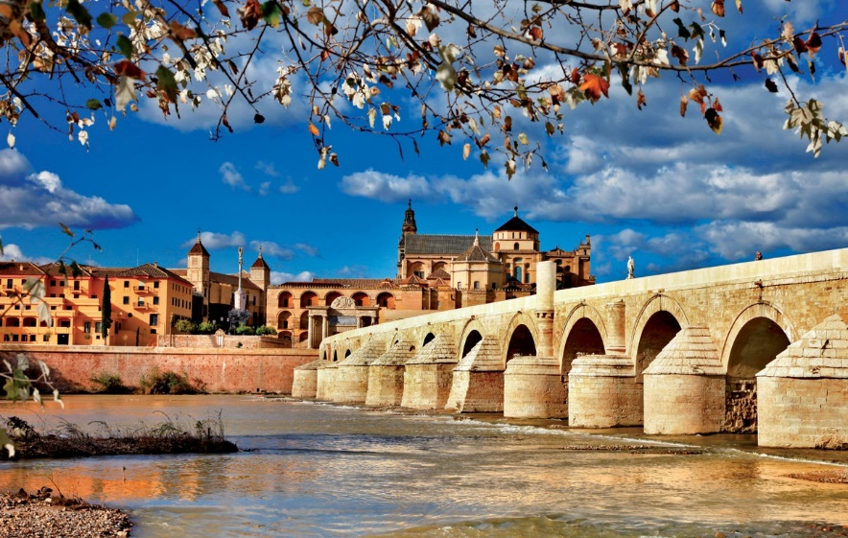

CORDOBA

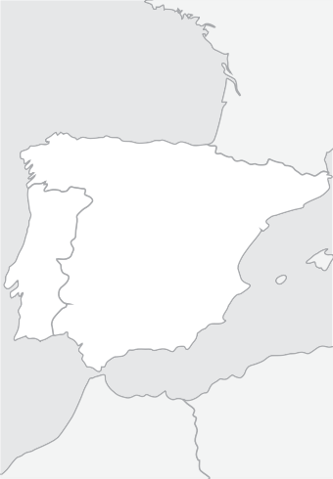

Madrid

Mérida

Lisbon Córdoba Seville

**PORTUGAL** Granada

Málaga

**SPAIN**

Porto

Fátima

Salamanca

Santiago

**Guaranteed Departure Tours**

**Spain & Portugal**

# From 1.345 €

15 days / 14 nights

Madrid - Segovia - Avila - Salamanca - Santiago de Compostela - Viana do Castelo - Porto - Fatima - Aveiro - Lisbon - Merida - Seville - Cordoba - Granada - Costa del Sol - Madrid

## Arrivals to Madrid: Monday

**2019**

|  |  |
| --- | --- |
| April | 01, 08, 15, 22, 29 |
| May | 06, 13, 20, 27 |
| June | 03, 10, 17, 24, 31 |
| July | 08, 15, 22, 29 |
| August | 05, 12, 19, 26 |
| September | 02, 09, 16, 23, 30 |
| October | 07, 14, 21, 28 |
| November | 04, 18 |
| December | 02, 16, 30 |
| 2020 |  |
| January | 13, 27 |
| February | 10, 24 |
| March | 02, 09, 16, 23, 30 |
| April | 06, 13, 20, 27 |

### Day 1, Monday: MADRID

Arrival at Madrid airport. After clearing simple immigration and customs formali- ties, you will be transferred to your First Class hotel. It is suggested you take ad- vantage of the free time to get to know one of Europe’s most dynamic capital cities. In the early evening, enjoy an “Il- luminated Madrid” drive through the bus- tling streets of the old city, ending at the historical and impressive Plaza Mayor. This area is home to some of the most typical restaurants and taverns, which serve the delicious “tapas”. PACKAGE includes a Tapas Dinner tonight. Return to your hotel at your own convenience. Accommodations.

### Day 2, Tuesday: MADRID

Buffet breakfast. This morning’s escorted sightseeing tour will allow you to get a

glimpse of some of Madrid’s most out- standing attractions, like the Puerta del Sol, the magnificent fountains of Neptune and Cibeles, the stately Alcala Gate, the busy Gran Via, the Plaza de España and the Plaza de Oriente Free afternoon to explore Madrid’s famous Art Museums or perhaps take an optional tour to the Im- perial former capital city of Toledo, where you will be escorted through its narrow cobblestone streets, soaking up the me- dieval atmosphere. Touring will include the interior of the magnificent Gothic cathedral and a visit to St. Tome Church, where El Greco’s masterpiece painting is displayed. Accomodations

### Day 3, Wednesday: MADRID - SE- GOVIA - AVILA - SALAMANCA

Buffet breakfast. Departure into old Cas- tile and the magnificent medieval city of Segovia, with its 2000 year old Roman aqueduct and impressive Alcazar Castle. Pause in Avila to admire the perfectly preserved 11th century city walls before continuing to the charming old university city of Salamanca. Afternoon city tour. PACKAGE includes a dinner. Tonight a walk through the beautiful main plaza, always lively with activity, is recom- mended. Accommodations

### Day 4, Thursday: SALAMANCA - SANTIAGO DE COMPOSTELA

Buffet breakfast. Departure toward the North of Spain, entering in Galicia. Ar- rival to the beautiful city of Santiago de Compostela. In the afternoon guided tour

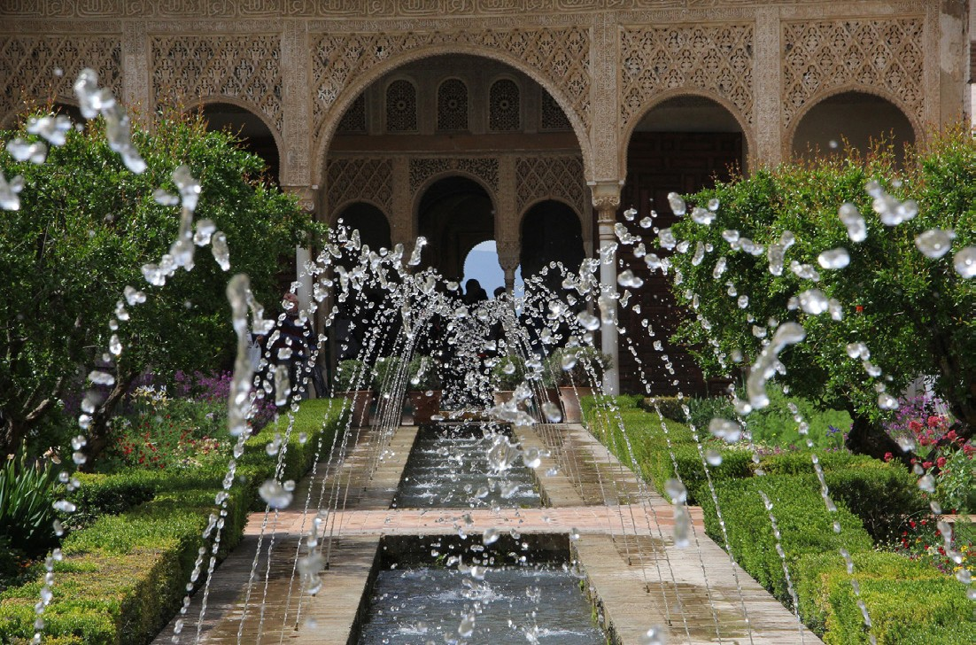of the old city of Santiago de Compost- ela and its beautiful Cathedral Tonight we can have in the Hotel a nice dinner. PACKAGE includes dinner. Ac- commodations.

### Day 5, Friday: SANTIAGO - VIANA DO CASTELO - PORTO

Breakfast buffet. Departure to Rias Baixas to continue our journey to Portugal. Visit the town of Viana do Castelo, in the mouth of the Lima River with its historic center and castle. Continue to Porto, capital of northern Portugal in the Douro region. Ac- commodation.

### Day 6, Saturday: PORTO

Buffet breakfast. local guided city visiting one local winery. PACKAGE includes a typical lunch. Afternoon free.

Accommodations.

### Day 7, Sunday: PORTO - AVEIRO - FATIMA - LISBON

Buffet breakfast and departure to Aveiro, the “city of canals” and known as the Venice of Portugal. Continue to Fatima one of the pilgrimage centers of Christi- anity. Free time to visit the basilica and lunch (Lunch included in PACKAGE) Continue to Lisbon. Tonight enjoy an optional opportunity to listen to the hauntingly beautiful Fado music while enjoying a delicious dinner. PACKAGE includes Fado show and dinner. Accommodations.

### Day 8, Monday: LISBON

Buffet breakfast. Morning tour of this ancient and lovely city overlooking the



#### TOUR FEATURES

P Transfers airport-hotel-airport

P Accommodations in hotels of Category Confort or Superior

#### OPTIONAL PACKAGE INCLUDES

15 DAYS: MADRID/MADRID: **295 €** · INCLUDES 9 MEALS AND 3 EXTRAS

P Bountiful buffet breakfast daily

P Deluxe air-conditioned motorcoach transportation

P Professional tour escort throughout (bilingual English/Spanish)

P Escorted sightseeing tours with bilingual guide in Madrid, Salamanca,Santiago de Compostela, Porto, Lisbon, Seville, Cordoba and Granada

P Evening Illuminations tour of Madrid

P Train Tickets Malaga/Madrid Fast Train AVE Tourist Class

P Travel bag

P “Tapas” dinner in Madrid

P Dinner in Salamanca P Dinner in Santiago P Lunch in Porto

P Lunch in Fatima

P Dinner and Fados Show in Lisbon

P Tour of Sintra and Cascais

P Lunch in Merida

P Lunch in Seville

P Flamenco Show in Seville

P Dinner in Granada

P Albaicin tour and show

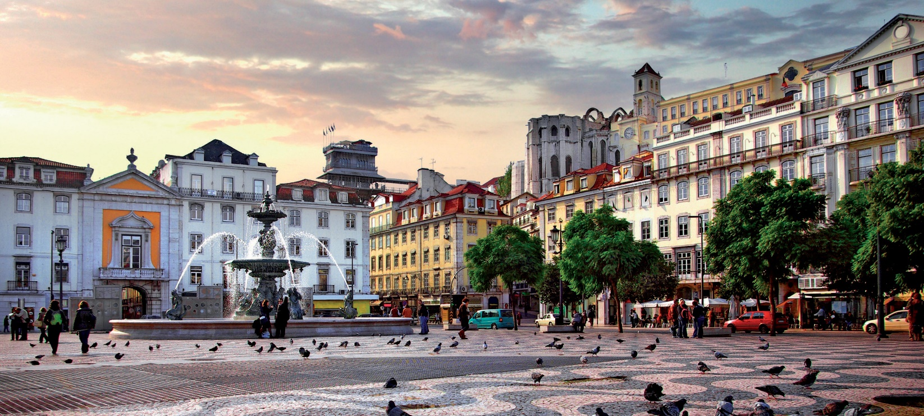

LISBON

Tagus River. Admire its splendid avenues and monuments like the Tower of Belem and the Jeronimos Monastery. Afternoon free, with a strong recommendation to visit the charming villages of Sintra and Cascais (this tour included in PACKAGE). Accommodations.

### Day 9, Tuesday: LISBON - MERIDA

- SEVILLE

Buffet breakfast. Departure toward the Spanish border, and pause in Merida to

### Day 11, Thursday: SEVILLE - COR- DOBA - GRANADA

Buffet breakfast. Depart to Cordoba. Visit one of the world’s marvels, the former Great Mosque (now a cathedral). Free time for lunch on your own. Continue to Granada, passing thousands of acres of olive groves. PACKAGE in- cludes dinner tonight. This evening, an excellent suggestion would be to visit (optional) the quaint and typical Albaicin quarter, where Andalusian customs, music

### Day 15, Monday: MADRID

Buffet Breakfast, Transfer to the airport.

|  |  |
| --- | --- |
|  | HOTELS USED  or similar |
| C | ategory Confort Hotels |
| Madrid  Salamanca Santiago Porto Lisbon Seville Granada  C. del Sol Madrid | Praga / Holiday Inn Piramides  Muralto / Chamartin  G.H. Corona Sol  Los Abetos G.H. / Tryp Santiago Park Hotel Gaia / Ibis Gaia  Exe Liberdade / Vip Zurique  M.A. Sevilla Congresos Abades Nevada Palace Hilton Garden  Praga / Holiday Inn Piramides Muralto / Chamartin |
| Ca | tegory Superior Hotels |
| Madrid  Salamanca Santiago Porto Lisbon Seville Granada  C. del Sol Madrid | Praga / Holiday Inn Piramides  Muralto / Chamartin  G.H. Corona Sol  Nh Collection / Hesperia Vigo Novotel Porto Gaia  Marriott / Acores / Real Palacio Melia Lebreros  G.H. Luna / Catalonia Hilton Garden  Praga / Holiday Inn Piramides Muralto / Chamartin |

April 01-08, 2019

Price per Person in Euros In Double / Twin room

Tour 15 days: Madrid / Madrid

Category Confort Hotels

April 15 / June 24

June 31 / August 19

August 26 / October 21

October 28 / March 23, 2020

March 30 / April 27, 2020

Supl. Single Room Apr 1/Oct 31, 2019 + Apr 2020 Supl. Single Room Nov 1, 2019 / Mar 31, 2020

1.580

1.475

1.465

1.345

1.345

1.570

575

490

admire the impressive Roman Amphithe-

and wine join to create an enchanting at-

Category Superior Hotels

atre archeological site. Lunch is included in PACKAGE. Continue to Se- ville. Accommodations.

### Day 10, Wednesday: SEVILLE

Buffet breakfast. This morning’s marve- lous tour will explore this gracious and charming city, Spain’s third largest. See the Tower of Gold, the tranquil and ex- tensive Maria Luisa Park, the quaint Santa Cruz Quarter, and finally the huge cathe- dral (one of the world’s largest) with its Giralda Tower (a former minaret). Free time for luncheon on your own. (Lunch Included in PACKAGE) The af- ternoon is free to continue to explore or shop. This evening an optional Flamenco Show is suggested, with the enjoyment of local wine. PACKAGE include Flamenco Show and drink. Accommodations.

mosphere. (PACKAGE includes this visit).

### Day 12, Friday: GRANADA - COSTA DEL SOL

Buffet breakfast. This morning, enjoy an escorted tour of the magnificent Alhambra and the verdant Gardens of the Generalife. Departure to the world-famous resort area of the Costa del Sol. Accommodations.

Day 13, Saturday: COSTA DEL SOL Buffet breakfast. Free day to enjoy this vacationer’s paradise. Accommodations.

### Day 14, Sunday: COSTA DEL SOL

- MADRID

Buffet Brealfast. Transfer to the rail sta- tion to take the fast train AVE to Madrid in Tourist Class. Arrive in Madrid and transfer to your Hotel for Accomodation.

The Night of May 10, 17, 24 & 31, June 07

and 14, October 11 & 25, 2019 will be reali- zed in Vigo and not in Santiago

April 01-08, 2019

April 15 / June 24

June 31 / August 19

August 26 / October 21

October 28 / March 23, 2020

March 30 / April 27, 2020

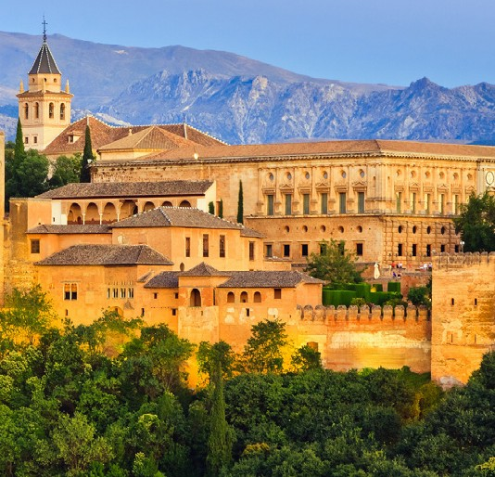Supl. Single Room Apr 1/Oct 31, 2019 + Apr 2020 Supl. Single Room Nov 1, 2019 / Mar 31, 2020

1.690

1.670

1.615

1.670

1.490

1.795

745

625

